Legendas:

Figure 1. Location of the municipality of Arambaré, Rio Grande do Sul.

Figure 2. Epomidiostomum sp.: A – Anterior region (10X); B – Female, showing vulva and eggs (40X); C – Female, showing the anus (10X); D – Male, showing the espicules (40X).

Figure 3. Cloacotaenia megalops: A - Scolex (10x); B – Mature proglottids (40X).

Figure 1.

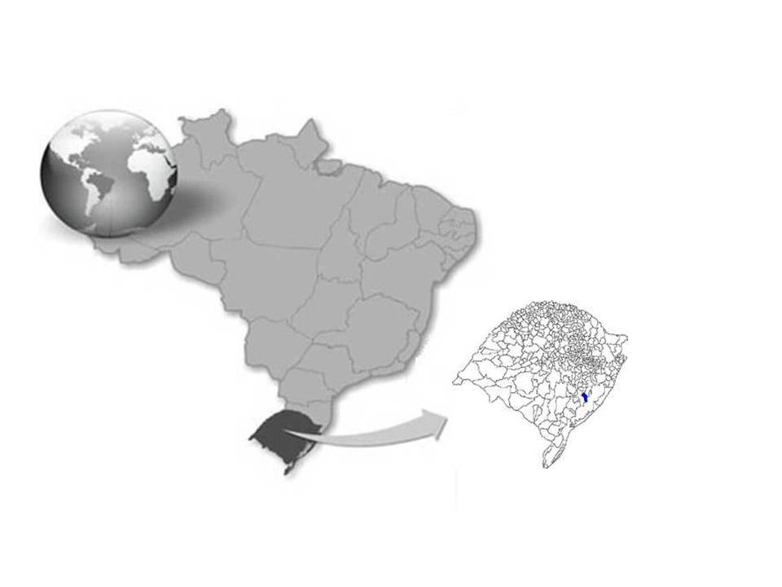

Figure 2.

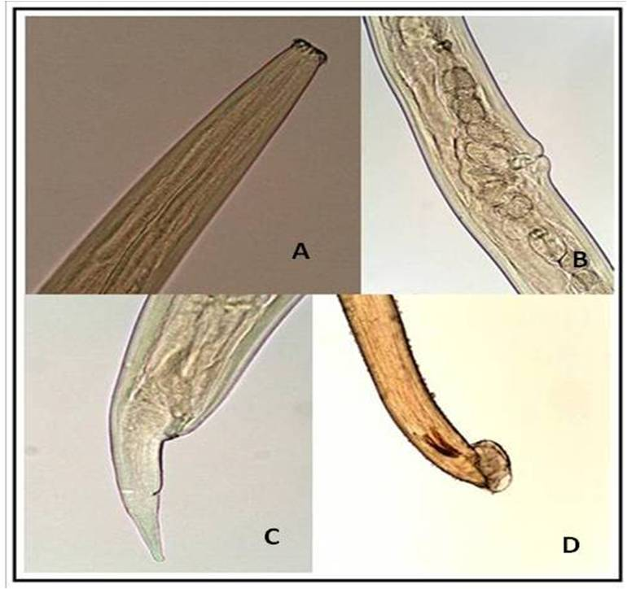

Figure 3.

