Table 1 – Frequency of cutaneous ADR by gender
16
51.6
15
48.4
31
100.0
F
M
Total
Valid
Frequency
%
p=0.857

Table 2 – Frequency of cutaneous ADR by age

Age | Number | %
0-10 | 1 | 3,2
11-20 | 0 | 0
21-30 | 2 | 6,45
31-40 | 6 | 19,35
41-50 | 1 | 3,2
51-60 | 6 | 19,35
61-70 | 8 | 25,8
71-80 | 6 | 19,35
81-90 | 1 | 3,2
Total | 31 | 100

Table 3 – Frequency of cutaneous ADR by ethnicity

2
1
67,74
10
32,25
31
100
Ethnicityy
White
Non-white
Total
Frequency
%
p = 0.048

Table 4 – Frequency of clinical manifestations in cases of cutaneous ADR
8
29,02
3
9,67
2
6,45

17
54,83

31
100
Erythema multiform
Fixed pigmented erythema
Ulcerative lesion
Papular scaly eczema
Total
Frequency
%

p=0.001

Table 5– Microscopic patterns of cutaneous ADR

p = 0, 001

Patterns | Subtypes | Frequency | %
Dermatite de interface | Vacuolar | 13 | 41,9
Dermatite de interface | Lichenoid | 4 | 12,9
Dermatite de interface | Lichenoid and vacuolar | 5 | 16,1
Psoriasis-like dermatitis | Espongiotic | 2 | 6,4
Psoriasis-like dermatitis | Pure | 5 | 16,1
Granulomatous |  | 2 | 6,4
Total |  | 31 | 100

Table 6 - Prevalence of captopril use among patients with cutaneous ADR

24
77.4
7
22.6
31
100.0
User
No
Yes
Total
Frequency
%

Table 7 - Relationship between vacuolar interface dermatitis pattern and captopril

Vacuolar Interface
Dermatitis
 |  | No | Yes | Total
Captopril | No | 15 62,5% | 9  37,5% | 24  100,0%
Captopril | Yes | 5  71,4% | 2  28,6% | 7  100,0%
Total |  | 20  64,5% | 11  35,5% | 31  100,0%

p=0,408

Annex 1 – Correlation of clinical manifestations and microscopic patterns
Cases | Clinical Presentation | Microscopy | Drugs
Case 1 | erythema multiforme | vacuolar interface dermatitis | Chloroquine / prednisone / Folic Acid
Case 2 | papular scaly eczematous lesion | vacuolar interface dermatitis | No Report
Case 3 | erythema multiforme | lichenoid interface dermatitis | No Report
Case 4 | erythema multiforme | vacuolar and lichenoid interface dermatitis | No Report
Case 5 | papular scaly eczematous lesion | vacuolar interface dermatitis | Captopril / Furosemide/ Nifedipine / Aspirin / Sinvastatin
Case 6 | fixed pigmented erythema | vacuolar interface dermatitis | Lamivudin /Zidovudin / Nevirapin /Omeprazole/  vitamins of B complex
Case 7 | fixed pigmented erythema | vacuolar interface dermatitis | No Report
Case 8 | erythema multiforme | vacuolar and lichenoid interface dermatitis | Captopril, hydrochlorothiazide, nifedipin, chlorpromazine, chlomipramine, flunarizine
Case 9 | psoriasiform lesion | pure psoriasis-like dermatitis | Carbamazepine
Case 10 | ulcerative lesion | lichenoid interface dermatitis | Captopril
Case 11 | papular scaly eczematous lesion | vacuolar interface dermatitis | No Report
Case 12 | erythema multiforme | Padrão granulomatoso | No Report
Case 13 | papular scaly eczematous lesion | vacuolar and lichenoid interface dermatitis | hydrochlorothiazide, Captoril, Anlodipine
Case 14 | papular scaly eczematous lesion | Padrão granulomatoso | No Report
Case 15 | psoriasiform lesion | pure psoriasis-like dermatitis | Captopril
Case 16 | erythema multiforme | vacuolar and lichenoid interface dermatitis | No Report
Case 17 | erythema multiforme | Dermatite psoriaseforme espongiótica | No Report
Case 18 | fixed pigmented erythema | vacuolar interface dermatitis | alendronate sodium,, captopril
Case 19 | papular scaly eczematous lesion | lichenoid interface dermatitis | Alprazolam, Ciproeptadin, Fluoxetin, Racumim, Creolin
Case 20 | papular scaly eczematous lesion | Dermatite psoriaseforme espongiótica | marijuana and cocaine
Case 21 | papular scaly eczematous lesion | vacuolar interface dermatitis | No Report
Case 22 | papular scaly eczematous lesion | vacuolar interface dermatitis | No Report
Case 23 | papular scaly eczematous lesion | vacuolar interface dermatitis | QT Ca Próstata/Captopril/ hydrochlorothiazide / Diazepan/ Ranitidin/ Aminofilin
Case 24 | papular scaly eczematous lesion | pure psoriasis-like dermatitis | No Report
Case 25 | papular scaly eczematous lesion | vacuolar interface dermatitis | Sustrate, Clonazepan, Vastarel  Selopress (metoprolol+ hydrochlorothiazide), aspirin
Case 26 | papular scaly eczematous lesion | vacuolar interface dermatitis | No Report
Case 27 | papular scaly eczematous lesion | vacuolar and lichenoid interface dermatitis | Cefalexine
Case 28 | papular scaly eczematous lesion | pure psoriasis-like dermatitis | Motilium/Label
Case 29 | erythema multiforme | vacuolar interface dermatitis | Dorflex,Clonazepan, alendronate sodium , calcium carbonate, Vitamin D
Case 30 | ulcerative lesion | lichenoid interface dermatitis | No Report
Case 31 | papular scaly eczematous lesion | pure psoriasis-like dermatitis | hydrochlorothiazide, Captopril, Nifedipine, Insulin

FIGURES
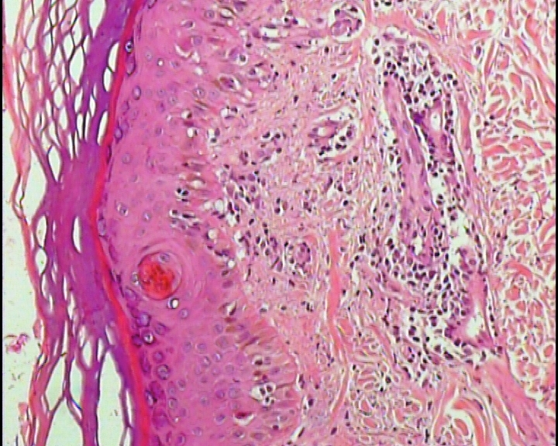
Figure 1. Interface dermatitis. HE 200X.
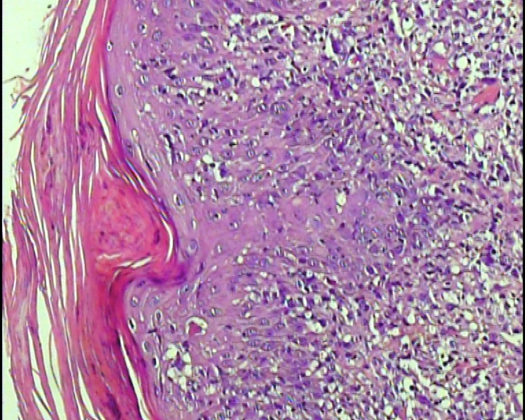
Figure 2. Lichenoid and vacuolar interface dermatitis. HE 200X.

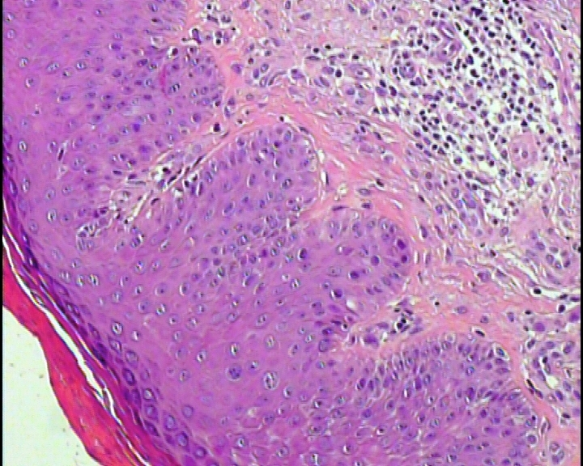

Figure 3. Psoriasis-like dermatitis. HE 200X.

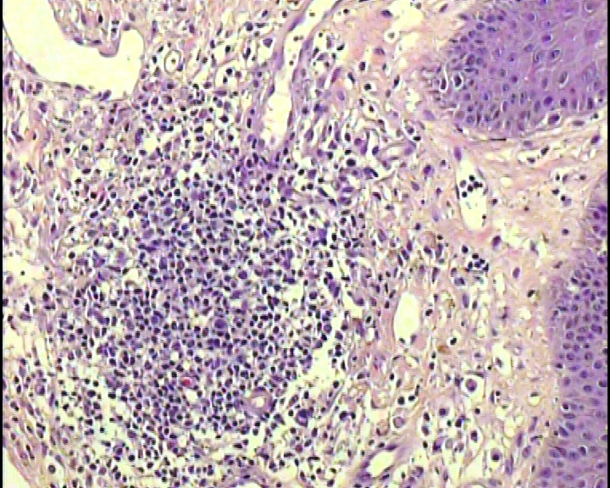
Figure 4. Granulomatous pattern. HE 400X.

