Figure 1

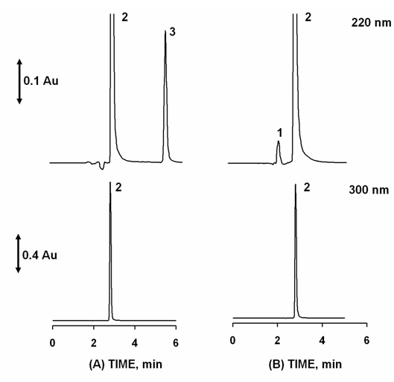

Figure 2

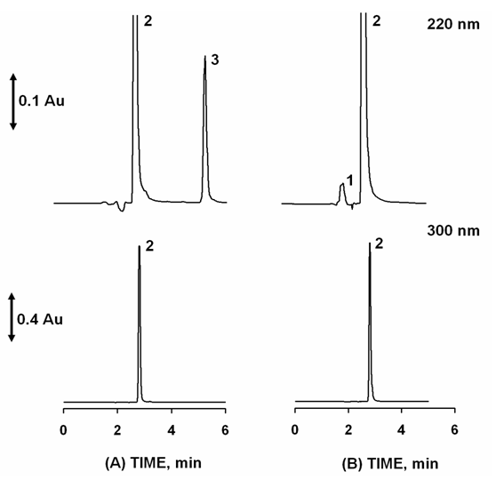

Table 1

 | Aceª | Pheª |  | Ace^{b} | Car^{b}
R^{c} | 8.5* |  |  | 3.2*
R^{c} | 8.5** |  |  | 3.1**
α^{c} | 2.6* |  |  | 3.6*
α^{c} | 2.6** |  |  | 3.5**
A/B^{c} | 1.3* |  | 1.2* | 1.5* |  | 1.5*
A/B^{c} | 1.2** |  | 1.2** | 1.5** |  | 1.5**
N/m^{c} | 200600* |  | 220000* | 58700* |  | 61433*
N/m^{c} | 204267** |  | 220167** | 58033** |  | 57067**
ªCommercial product 1, ^{b}commercial product 2, ^{c}Mean (n=6), *Standards; **standards + pharmaceutical excipients
Fonte: Os autores (2009).

Table 2

 | Slope | Intercept | r | p-value^{c}
Aceª | 9 591  (±132.82) | 260497  (±58987) | 0.999 | 0.088
Pheª | 75 277  (±732.44) | -9 950  (±16775) | 0.999 | 0.010
Ace^{b} | 11 272  (±72.55) | -89 084  (±29568) | 0.999 | 0.316
Car^{b} | 79 442  (±1758.46) | 23 080  (±7135) | 0.997 | 0.793
ªCommercial product 1, ^{b}commercial product 2, ^{c}Shapiro-Wilk Normality Test
Fonte: Os autores (2009).

Table 3

 | Aceª | Pheª | Ace^{b} | Car^{b}
Repeatability^{c} | 0.15* | 0.06* | 0.08* | 0.43*
Repeatability^{c} | 0.11** | 0.28** | 0.07** | 0.62**
Intermediate precision^{c} | 1.45* | 0.52* | 0.12* | 3.25*
Intermediate precision^{c} | 0.14** | 2.45** | 0.89** | 0.21**
LOD | 6.57** | 1.12** | 12.51** | 0.84**
LOQ | 21.89** | 3.74** | 41.69** | 2.79**
ªCommercial product 1, ^{b}commercial product 2, ^{c}Mean (n=6), *Standards; **standards + pharmaceutical excipients
Fonte: Os autores (2009).

Table 4

 | Added amount (mg) | Found amount ^{c} | Recovery (%)
 | 351.79 | 356.33 ± 0.10 | 101
 | 395.77 | 397.67 ± 0.04 | 100
Aceª | 439.74 | 441.50 ± 0.10 | 100
 | 483.71 | 482.19 ± 0.16 | 100
 | 527.69 | 516.14 ± 0.07 | 98
 |  |  | 100^{d}
 | 17.78 | 17.53 ± 0.32 | 99
 | 20.01 | 19.52 ± 0.12 | 98
Pheª | 22.23 | 21.56 ± 0.14 | 97
 | 24.45 | 24.26 ± 0.96 | 99
 | 26.68 | 26.41 ± 0.20 | 99
 |  |  | 98^{d}
 | 322.82 | 319.14 ± 0.02 | 99
 | 363.17 | 358.99 ± 0.33 | 99
Ace^{b} | 403.52 | 399.28 ± 0.09 | 99
 | 443.87 | 442.80 ± 0.03 | 100
 | 484.22 | 481.39 ± 0.46 | 99
 |  |  | 99^{d}
 | 3.21 | 3.26 ± 4.30 | 101
 | 3.62 | 3.51 ± 1.17 | 97
Car^{b} | 4.02 | 3.88 ± 0.22 | 97
 | 4.42 | 4.34 ± 1.29 | 98
 | 4.82 | 4.70 ± 1.58 | 97
 |  |  | 98^{d}
ªCommercial product 1, ^{b}commercial product 2, ^{c}Mean (n=3); ^{d}mean of recovery range
Fonte: Os autores (2009).

Table 5

Experiments | 1 | 2 | 3 | Aceª | Pheª | Ace^{b} | Car^{b}
A^{c} | - | 0 | 0 | 101.0 | 100.5 | 101.1 | 100.7
B^{c} | + | 0 | 0 | 102.0 | 99.6 | 100.9 | 100.7
C^{c} | 0 | - | 0 | 100.2 | 104.3 | 100.7 | 100.5
D^{c} | 0 | + | 0 | 100.7 | 102.7 | 100.0 | 100.2
E^{c} | 0 | 0 | - | 101.1 | 104.4 | 100.2 | 101.8
F^{c} | 0 | 0 | + | 100.8 | 104.0 | 101.3 | 101.2
G^{c} | 0 | 0 | 0 | 100.3 | 102.3 | 101.6 | 100.6
1- Mobile phase (%MeOH): (-) 55; (0) 60; (+) 65; 2- Flow (mL min⁻¹): (-) 0.7; (0) 1.0; (+) 0.4ª/ 1.3^{b} ; 3- pH: (-) 3.1; (0) 4.1; (+) 5.1. ªCommercial product 1, ^{b}commercial product 2, ^{c}Mean (n=6)
Fonte: Os autores (2009).

